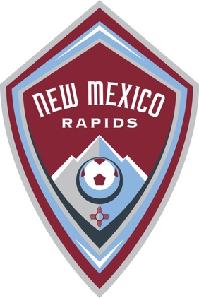
NM Rapids S.C. Request for Contribution Check
Form must be completed and submitted with the contribution check prior to funds being distributed to the team. Checks and this form should be mailed to: NM Rapids SC Attn: Treasurer, 8220 La Mirada NE Suite 600, Albuquerque, New Mexico, 87109.
NM Rapids SC is a non-profit 501(c) Corporation, Employer ID Number: 31-1655044. This number may only be used by the contributor and may not be used for individual NM Rapids teams.
Contribution From:

Check Number and Amount:

Date Requested:
Requested By (Team Name):

Check Made Payable To:

Address Check Mailed To:

Contact Person For Team:

Contact Person Information:

Special Instructions:
For NM Rapids SC Use Only
Date Received: __________________________________
Date Check Deposited: __________________________________
Treasurer Approval: __________________________________

